1.1 - *I can understand how to represent a region on a graph with an inequality.*

*1.2 - I can understand real-world situations that can be modeled as linear relationships with constraints.*

**Graph the following inequalities.**

$1. y≥\frac{1}{2}x+5$ 2.

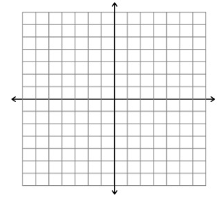

**Write an inequality for each graph.**

3. __________________ 4. _____________________

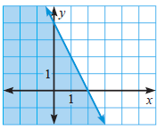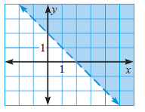

**5. Graph** 2x – 5y > 10.

Which of the ordered pairs is **NOT**

a solution of the inequality?

1. (2, -2) c) (3, -1)
2. (5, -1) d) (0, -2)

6. Tickets for the school play cost $5 per student and $7 per adult. The school wants to earn at least $5400 on each performance.

1. Write an inequality that represents this situation __________________________
2. 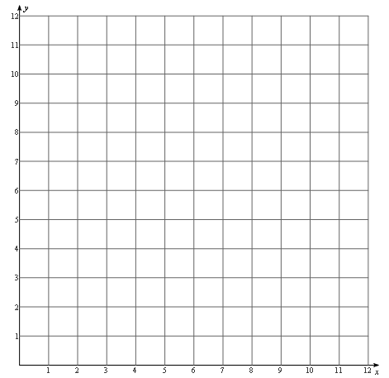Graph the inequality:
3. Choose a point that **IS** a solution to the inequality. **EXPLAIN** what it means in the context of the problem.